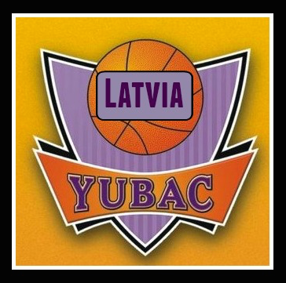

YUBAC Latvia – International basketball camp created as a partnership’s project between YUBAC and CDW Minerals.

YUBAC (Yugoslavian Basketball Camp http://www.yubac.rs/about-us/history/) was founded in Belgrade, in 1993. Respecting the great reputation of Yugoslav basketball school and our eminent experts, we set ourselves very high goals from the start. The quality of our program, as well as the enthusiastic, dedicated and competent camp staff which takes care of every single detail – from accommodation to entire training program, created our reputation in European basketball circles.

Since 1998 we work with Yugoslav Basketball Association License as a quality guarantee. Even though we were skeptical about the success of the following 1999, around 600 boys and girls who came on YUBAC inspire of bombing denied Yugoslavian theory.

2001 we signed contract with the company “Genex” and reached the top of Kopaonik, while in basketball circles we were already synonym for top camp. NBA player Vladimir Radmanović came on YUBAC. We also started with the camp for referees. Next year 2002, we had 3000 participants from 41 countries and 4 continents. 98 guards and 89 shooters without thinking came to the right place – YUBAC.

As the only basketball camp in Europe, at the year 2003 we got the FIBA license. With Five Star, the most famous camp in USA, that year we organized a cooperative camp with their program, which represents their first presence in Europe. The cooperation will be enhanced…

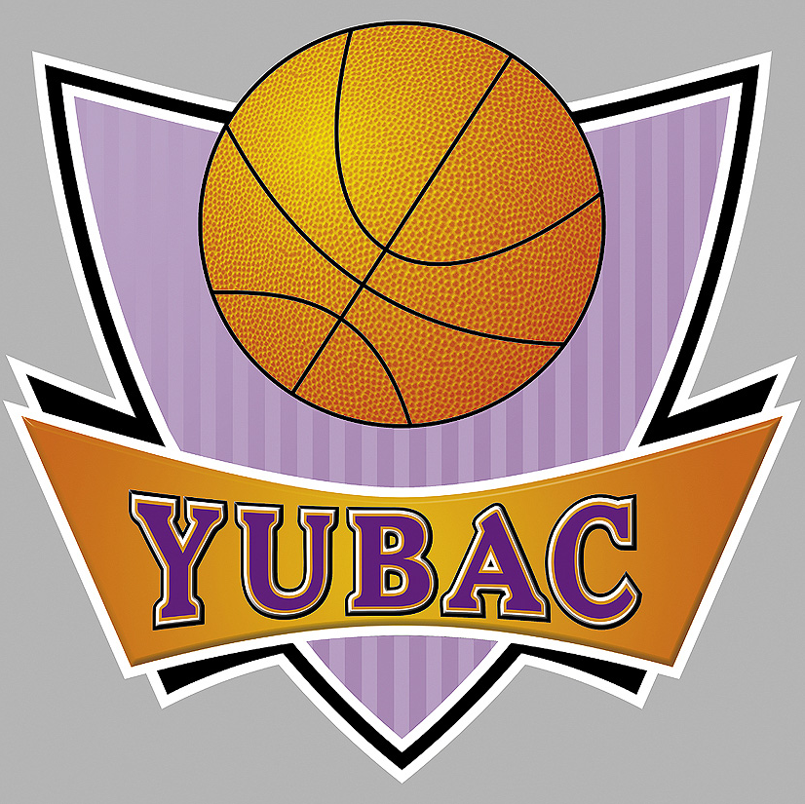
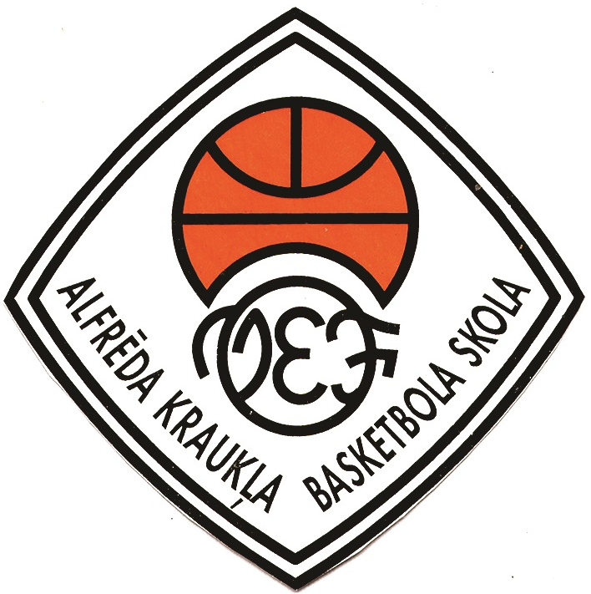
November, 2015 – Milan Opacic, owner of YUBAC, visited Riga and showed interest in “YUBAC Latvia” project. He estimated big potential and prospective in hosting “YUBAC Latvia” international basketball camp in Malpils. The first YUBAC Latvia Pro-Camp was held in Riga in December, 2015. The camp was a success and we would like to thank Serbian coach Viktor Antic for his professional way of doing his job and his experience that gave a great foundation for individual skills for the new players. After the first camp the parents decided to go for one more Pro-Camp during the Spring Holidays in March,2016. Now that we got our first indispensable experience form those two weeks in Latvia; YUBAC is ready for their first summer camp in Malpils, Latvia on June, 2016.

