Deutsche Sporthochschule Köln . 50927 Köln

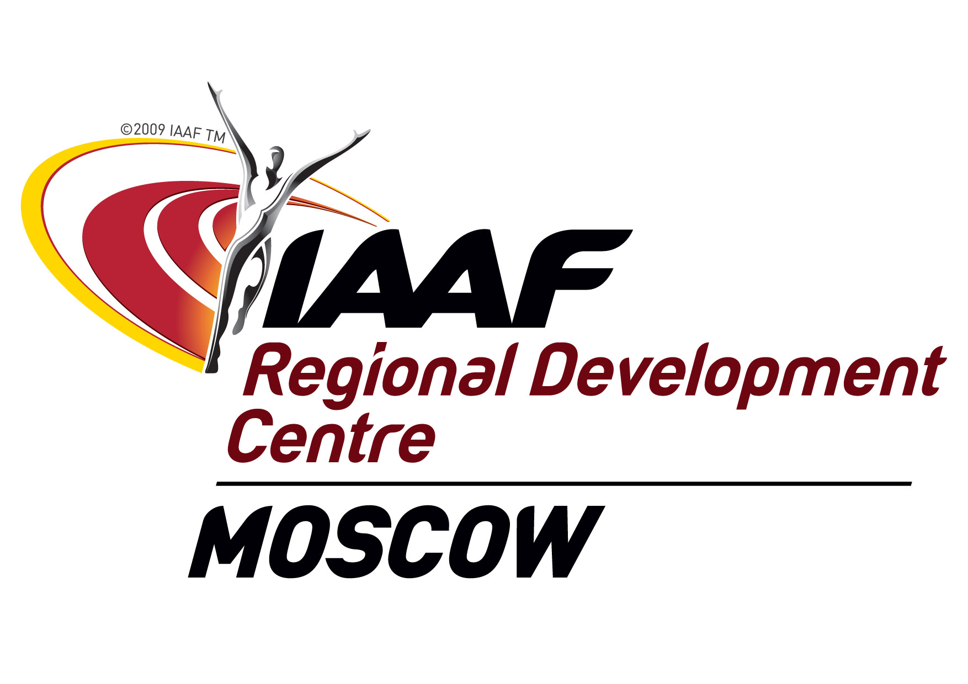
IAAF CECS PILOT COURSE
LEVEL III JUMPS
April 20 – May, 3

Am Sportpark Müngersdorf 6
50933 Köln . Deutschland
Telefon +49(0)221 4982-4180
Telefax +49(0)221 4973454
ritzdorf@dshs-koeln.de
www.dshs-koeln.de

Dr. Wolfgang Ritzdorf
Vice head

Institut für Bewegungs-
und Neurowissenschaft
Institute of Movement
and Neurosciences

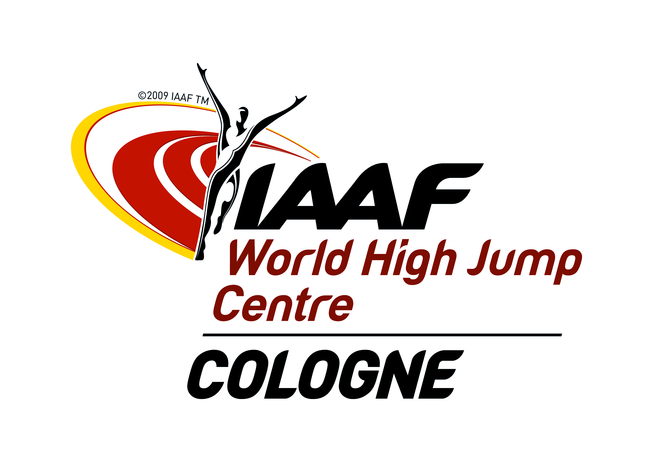

EAA
Member Federations

Dear Colleagues,

German Sport University Cologne and IAAF RDC Moscow will organize a CECS LEVEL III Pilot Course “Jumps” to be held at German Sport University from April 20 – May, 3.

Please find some details:

Course
CECS Level III course is the first event group specific programme within the CECS system. Main course contents are technique and training of the jumping events, both theoretically and practically. Session planning and general theory lectures complete the course schedule.

Lecturers
- Dr. Wolfgang Ritzdorf
Vice head of department German Sport University
IAAF Senior Lecturer and responsible author for the Level III and IV jumps material
Director IAAF World High Jump Centre
Active coach
- Dr. Falk Schade
Olympic Training Centre Cologne
Biomechanist
Active coach

- Tillmann Bockhorst
Lecturer German Sport University
NOC lecturer
Active coach

Location

The German Sport University Cologne is the only Sport University in Germany. It has gained a worldwide reputation for excellence and is a highly recognised institution in sciences and education in sport world-wide.
It provides all facilities for both theory and practical. For more information please check www.atc-cologne.de

Accommodation

Participants will stay at the guesthouse of the university sharing double room. The guesthouse is within walking distance to the course locations.
Meals will be taken in the guesthouse or the university’s dining hall.

Travel

Participants should arrive at Cologne/Bonn airport on April, 19. Upon arrival please move to the Meeting Point in Terminal II (D). We will pick you up there.
For arrivals in Düsseldorf: Please take the sky train to the train station. Get a ticket to Köln Junkersdorf via Köln Messe/Deutz. Change the platform in Köln Messe/Deutz and take the STR 1 (tram) direction Weiden West. Leave the STR 1 at station Junkersdorf. You are on the campus of German Sport University and in walking distance to the guesthouse.
Return flights should be booked for May, 4.

Visa
In case you need a visa please contact Marlen Spielvogel (m.spielvogel@dshs-koeln.de) for an invitation letter.

Language of the course
The Course is conducted in English. It is planned that the same kind of course will be organized in Moscow in Russian in 2014.

Finances
RDC Moscow covers the expenses for full board accommodation for one participant from each National Federation for the period 19th April – 4th May and covers the return ticket expenses from the place of living to Cologne not exceeding 500 US dollars per ticket. All the participants must bring invoices and bank details for reimbursement.

Participation Confirmation
Please confirm course participation by 1st of April.



Kind regards

Dr. Wolfgang Ritzdorf Vadim Zelichenok
German Sport University IAAF RDC Moscow

